160. Intersection of Two Linked Lists

Easy

1852140FavoriteShare

Write a program to find the node at which the intersection of two singly linked lists begins.

For example, the following two linked lists:

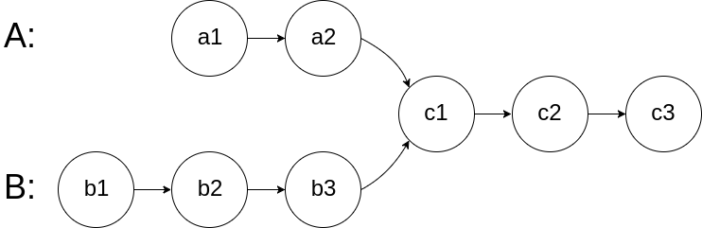

begin to intersect at node c1.

Example 1:

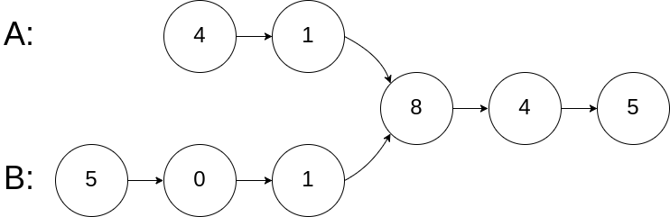

Input: intersectVal = 8, listA = [4,1,8,4,5], listB = [5,0,1,8,4,5], skipA = 2, skipB = 3  
Output: Reference of the node with value = 8  
Input Explanation: The intersected node's value is 8 (note that this must not be 0 if the two lists intersect). From the head of A, it reads as [4,1,8,4,5]. From the head of B, it reads as [5,0,1,8,4,5]. There are 2 nodes before the intersected node in A; There are 3 nodes before the intersected node in B.

Example 2:

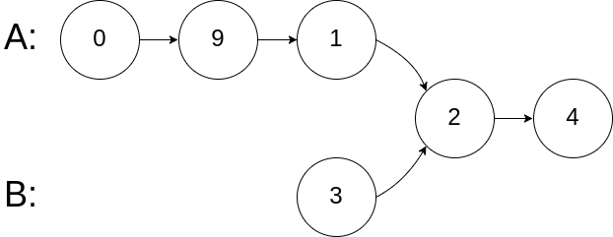

Input: intersectVal = 2, listA = [0,9,1,2,4], listB = [3,2,4], skipA = 3, skipB = 1  
Output: Reference of the node with value = 2  
Input Explanation: The intersected node's value is 2 (note that this must not be 0 if the two lists intersect). From the head of A, it reads as [0,9,1,2,4]. From the head of B, it reads as [3,2,4]. There are 3 nodes before the intersected node in A; There are 1 node before the intersected node in B.

Example 3:

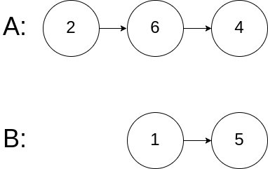

Input: intersectVal = 0, listA = [2,6,4], listB = [1,5], skipA = 3, skipB = 2  
Output: null  
Input Explanation: From the head of A, it reads as [2,6,4]. From the head of B, it reads as [1,5]. Since the two lists do not intersect, intersectVal must be 0, while skipA and skipB can be arbitrary values.  
Explanation: The two lists do not intersect, so return null.

/**

* Definition for singly-linked list.

* struct ListNode {

* int val;

* ListNode *next;

* ListNode(int x) : val(x), next(NULL) {}

* };

*/

class Solution {

public:

ListNode *getIntersectionNode(ListNode *headA, ListNode *headB) {

ListNode* ptr1=headA,*ptr2=headB;

while(ptr1!=ptr2){

ptr1=ptr1?ptr1->next:headB;

ptr2=ptr2?ptr2->next:headA;

}

return ptr1;

}

};

Success

[Details](https://leetcode.com/submissions/detail/211552576/)

Runtime: 52 ms, faster than 98.07% of C++ online submissions forIntersection of Two Linked Lists.

Memory Usage: 16.7 MB, less than 57.45% of C++ online submissions forIntersection of Two Linked Lists.